Louisiana Community Health Worker Core Competency Training Program Approval Process and Application

Louisiana Community Health Worker Workforce Coalition
Email: LACHWCoalition@gmail.com

Table of Contents
COMMUNITY HEALTH WORKERS 3
THE CHW WORKFORCE IN LOUISIANA 4
History 4
Louisiana CHW Workforce Study 4
Louisiana CHW Workforce Coalition 4
CHW CORE COMPETENCIES 6
CHW Core Competencies and Skills 6
Louisiana CHW Workforce Coalition CHW Core Competency TRAINING PROGRAM APPROVAL PROCESS 9
Louisiana CHW Workforce coaltion CHW Core Competency TRAINING PROGRAM APPROVAL APPLICATION 13
CHW Core Competency Crosswalk 15
Supporting documentation 19

COMMUNITY HEALTH WORKERS

Community health workers (CHWs) are frontline public health workers who are trusted members of and/or have an unusually close understanding of the community served. This trusting relationship enables CHWs to serve as a liaison/link/intermediary between health/social services and the community to facilitate access to services and improve the quality and cultural competence of service delivery. CHWs also build individual and community capacity by increasing health knowledge and self-sufficiency through a range of activities, including outreach, community education, informal counseling, social support, and advocacy. - American Public Health Association
Additional information and answers to frequently asked questions about CHWs can be found here.

CHWs work in a wide variety of settings including :
Health clinics such as Federally Qualified Health Centers and hospitals
Medicaid Managed Care Organizations
State and local health departments
Community-based organizations
Universities
Schools and community centers

THE CHW WORKFORCE IN LOUISIANA

History
CHWs have been working in communities across Louisiana for decades. In 2010, CHWs and allies created the Louisiana Community Health Outreach Network (LACHON) to serve as a professional organization for CHWs. Run by and for CHWs, LACHON provides training and education for CHWs and supervisors. It also offers mentorship, professional development, networking opportunities, and resources for CHWs. The Louisiana CHW Institute was also established in 2010 to support CHW workforce development through training for CHWs and supervisors. The Louisiana CHW Institute also conducts research and offers technical assistance on CHW program development, financing, and evaluation to state health agencies, community-based organizations, health systems, and social service organizations.

Louisiana CHW Workforce Study
In 2019, the Louisiana Legislature created the Louisiana Community Health Worker Workforce Study Committee (Committee) to provide the Louisiana Department of Health with recommendations on how best to expand and support the CHW workforce statewide. The Committee examined major CHW policy issues, including options for training CHWs and financing their positions. In addition to reviewing best practices and examining peer-reviewed literature, the Committee collected data about Louisiana CHW and employer perspectives on workforce development issues through a survey and in-depth interviews. Based on the findings, the Committee made formal recommendations about how best to support and expand the CHW workforce. These included creating the Louisiana CHW Workforce Coalition to implement the recommendations, developing a process to review and approve state-recognized standardized CHW core competency training programs, and working to develop a sustainable method to finance CHW positions.

Louisiana CHW Workforce Coalition
In early 2020, the Committee became the Louisiana CHW Workforce Coalition. The members include CHWs, and staff from a variety of organizations including the Louisiana Office of Public Health, community-based organizations, Federally Qualified Health Centers, health systems, and other agencies. A subset of members formed the CHW Training Subcommittee, which developed the Louisiana CHW Core Competency Training Program Approval Process and Application throughout 2020 and early 2021. The Coalition requested that LACHON coordinate the review of CHW training programs that apply to be recognized by the Louisiana CHW Workforce Coalition.

CHW CORE COMPETENCIES

In 2016, the Community Health Worker Core Consensus (C3) Project published a report based on national research that outlined CHW core competencies and associated skills. The Louisiana CHW Workforce Coalition has recommended that these competencies serve as the backbone for CHW training programs in Louisiana.

CHW Core Competencies and Skills
CORE COMPETENCIES | ASSOCIATED SKILLS
Communication Skills | Ability to use language confidently
 | Ability to use language in ways that engage and motivate
 | Ability to communicate using plain and clear language
 | Ability to communicate with empathy
 | Ability to listen actively
 | Ability to prepare written communication including electronic communication (e.g., email, telecommunication device for the deaf)
 | Ability to document work
 | Ability to communicate with the community served (may not be fluent in language of all communities served)
Interpersonal and Relationship Building Skills | Ability to provide coaching and social support
 | Ability to conduct self-management coaching
 | Ability to use interviewing techniques (e.g., motivational interviewing)
 | Ability to work as a team member
 | Ability to manage conflict
 | Ability to practice cultural humility
Service Coordination and Navigation Skills | Ability to coordinate care (including identifying and accessing resources and overcoming barriers)
 | Ability to make appropriate referrals
 | Ability to facilitate development of an individual and/or group action plan and goal attainment
 | Ability to coordinate CHW activities with clinical and other community services
 | Ability to follow-up and track care and referral outcomes
Capacity Building Skills | Ability to help others identify goals and develop to their fullest potential
 | Ability to work in ways that increase individual and community empowerment
 | Ability to network, build community connections, and build coalitions
 | Ability to teach self-advocacy skills
 | Ability to conduct community organizing to address community health issues
Advocacy Skills | Ability to contribute to policy development
 | Ability to advocate for policy change to improve community health
 | Ability to speak up for individuals and communities
Education and Facilitation Skills | Ability to use empowering and learner-centered teaching strategies
 | Ability to use a range of appropriate and effective educational techniques
 | Ability to facilitate group discussions and decision-making
 | Ability to plan and conduct classes and presentations for a variety of groups
 | Ability to seek out appropriate information and respond to questions about pertinent topics
 | Ability to find and share requested information
 | Ability to collaborate with other educators
 | Ability to collect and use information from and with community members
Individual and Community Assessment Skills | Ability to participate in individual assessment through observation and active inquiry
 | Ability to participate in community assessment through observation and active inquiry
Outreach Skills | Ability to conduct case-finding, recruitment and follow-up
 | Ability to prepare and disseminate materials
 | Ability to build and maintain a current resource inventory
Professional Skills and Conduct | Ability to set goals and to develop and follow a work plan
 | Ability to balance priorities and to manage time
 | Ability to apply critical thinking techniques and problem solving
 | Ability to use pertinent technology
 | Ability to pursue continuing education and lifelong learning opportunities
 | Ability to maximize personal safety while working in community settings (e.g. during community outreach or home visits)
 | Ability to observe ethical and legal standards (e.g., CHW Code of Ethics, Americans with Disabilities Act [ADA], Health Insurance Portability and Accountability Act [HIPAA])
 | Ability to identify situations calling for mandatory reporting and carry out mandatory reporting requirements
 | Ability to participate in professional development of peer CHWs and in networking among CHW groups
 | Ability to set boundaries and practice self-care
Evaluation and Research Skills | Ability to identify important concerns and conduct evaluation and research to better understand root causes
 | Ability to apply the evidence-based practices of Community Based Participatory Research (CBPR) and Participatory Action Research (PAR)
Ability to participate in evaluation and research processes including:
- Identifying priority issues and evaluation/ research questions
- Developing evaluation/research design and methods
- Data collection and interpretation
- Sharing results and findings
- Engaging stakeholders to take action on findings
Knowledge Base | Knowledge about social determinants of health and related disparities
 | Knowledge of the causes of health disparities
 | Knowledge of institutionalized racism and how it contributes to health disparities
 | Knowledge base around special populations (e.g., formerly incarcerated people)
 | Knowledge about pertinent health issues
 | Knowledge about healthy lifestyles and self-care
 | Knowledge about mental/behavioral health issues and their connection to physical health
 | Knowledge about health behavior theories
 | Knowledge of basic public health principles
 | Knowledge about the community served
 | Knowledge about United States health and social service systems

References
American Public Health Association, 2017. “Community Health Workers.” Retrieved December 15, 2020 from https://www.apha.org/apha-communities/member-sections/
community-health-workers .

Rosenthal, E.L., Rush, C.H. & Allen, C.G. (2016). Understanding Scope and Competencies: A Contemporary Look at the United States Community Health Worker Field. Progress Report of the CHW Core Consensus (C3) Project: Building National Consensus on CHW Core Roles, Skills and Qualities. Retrieved December 15, 2020 from https://sph.uth.edu/dotAsset/28044e61-fb10-41a2-bf3b- 07efa4fe56ae.pdf

Louisiana CHW Workforce Coalition CHW Core Competency TRAINING PROGRAM APPROVAL PROCESS

Agencies that wish to have a CHW core competency training program recognized in Louisiana may submit an application for review by the Louisiana CHW Workforce Coalition. Training programs must focus on CHW core competencies as defined by the Community Health Worker Core Consensus project (www.c3project.org). The Louisiana CHW Workforce Coalition does not currently review training programs related to specific health conditions (e.g., chronic disease, HIV) or specific job duties that CHW employers may require.

The training program approval process has two components: 1) an application that must outline the proposed program structure, curriculum, and training philosophy, and 2) an in-person or virtual site visit with the review committee. Additional details on submission requirements are below. Every effort will be made to complete the review process within 90 days of submission of a complete application.

Louisiana CHW Workforce Coalition CHW Core Competency Training Program Approval Process Diagram

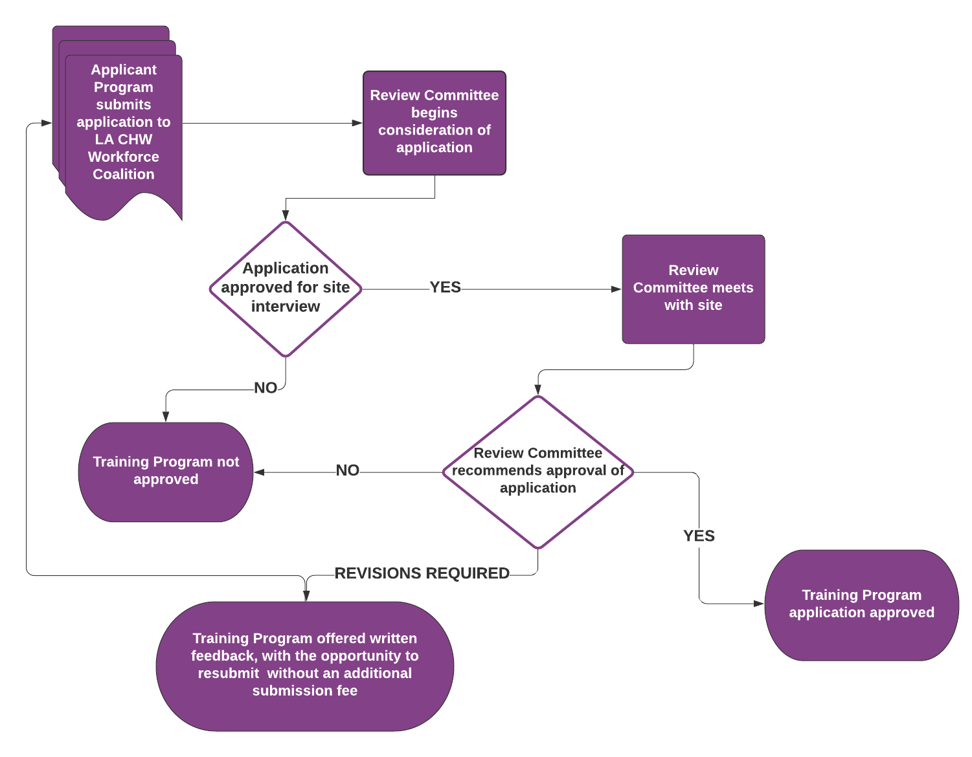

The Louisiana CHW Workforce Coalition CHW Core Competency Training Program Approval Process includes the following steps:
- Application Submission, including the $650 application fee payable to LACHON.
  - Submission can be completed two ways: email or by mail. Email is preferred.
    - Email submissions: Send one email with all components of the application attached to: LACHWCoalition@gmail.com.
    - Mail submissions: Send three (3) copies of all materials to LACHON at the address below. Please also send an email to LACHWCoalition@gmail.com notifying us of your submission so that we can be on the lookout for your application.
LACHON
2030 Oretha Castle Haley Blvd.
New Orleans, LA 70113
  - Fee submission: The $650 fee is assessed to cover the cost of time to review materials, conduct site visits, and provide written feedback to applicant programs, as needed. Fees can be either submitted online at www.lachon.org under the donate button or by check sent to the address above for LACHON. Please note that submissions will not be reviewed until the fee is received.

- Application Review
  - A Review Committee made up of three members of the Louisiana CHW Workforce Coalition will review the application and included materials to determine if an Applicant Site Visit is granted.
- Applicant Site Visit (if granted)
  - The Review Committee and the Applicant Program will discuss materials submitted, training logistics, and any questions about the curriculum. The Applicant Program’s proposed training facilitators, including a CHW, must attend this visit.
- Decision from Review Committee
  - If approved, Applicant Program will be notified by email of approval. Approvals are valid for three (3) years. If instructors change within the three-year period, updated instructor information must be submitted to the Review Committee within 90 days.
  - If denied, the Review Committee will provide via email written feedback and the Applicant Program will be allowed to make revisions and resubmit within six months at no additional cost.

After a complete application is submitted and application fee received, the Review Committee will evaluate all materials submitted with the Applicant Program’s application. All efforts will be made to complete the entire process of application review, site visit, and decision notification within 90 days of submission.
If the Review Committee provides initial approval of the written application, the Applicant Program will be contacted via email to schedule a site visit with the Review Committee members. This site visit will allow the Review Committee and the Applicant Program to discuss any concerns or provide any supporting material for their application. Participants from the Applicant Program should include program leaders and trainers, including a CHW who will serve as a training facilitator.
If the application is denied at any point, the Review Committee will notify the Applicant Program via email and provide written feedback about the reason(s) for denial. Some applicants may be granted the opportunity to make revisions and resubmit their materials. In these cases, the Applicant Program will have six months from the date of the denial notification to re-submit the application, and the submission fee will not be reassessed.
Please note that all Review Committee members will be assessed for conflicts of interest prior to reviewing materials. Furthermore, materials submitted for review will not be shared with anyone outside of the Review Committee or duplicated in any way.
The Louisiana CHW Workforce Coalition will maintain a list of approved CHW Core Competency Training Programs. Approval will be valid for three (3) years. The renewal process will require Training Programs to submit documentation of how, if at all, their training program has changed.

Louisiana CHW Workforce coaltion CHW Core Competency TRAINING PROGRAM APPROVAL APPLICATION

Agencies that wish to have a CHW core competency training program recognized in Louisiana may submit an application for review by the Louisiana CHW Workforce Coalition. Submissions are allowed by email or mail.
Email submissions: Send one email with all components of the application attached to: LACHWCoalition@gmail.com. Submit the $650 review fee at www.lachon.org using the donate button.
Mail submissions: Send three (3) copies of all materials to LACHON at the address below,
along with a check for the $650 review fee to LACHON.
LACHON
2030 Oretha Castle Haley Blvd.
New Orleans, LA 70113
Please also send an email to LACHWCoalition@gmail.com notifying us of your
submission so that we can be on the lookout for your application.

The application includes three components:
- Application Form (see from below)
- Core Competency Crosswalk (see form below)
- Supporting documentation (see description below)
  - Syllabus
  - Description of Training Location and Facilities
  - Lesson Plans
  - CHW Involvement in Curriculum Design
  - Enrollment Criteria for Students
  - Assessment Process
  - Trainer Experience/Qualifications
  - Training Philosophy
  - Fees
LOUISANA CHW WORKFORCE COALITION
CHW CORE COMPETNCY TRAINING PROGRAM APPLICATION FORM

This application must be submitted either by email or by mail, along with supporting documentation and payment. Please note that an application is good for only one training program site and all instructors must be listed. If a program wishes to operate in multiple locations simultaneously, with separate instructors in each location, a separate application must be submitted for each site and set of instructors. All efforts will be made to deliver a decision within 90 days of receiving the application. If an application is not approved, the applicant will have one opportunity to re-submit without submitting additional payment. Please print or type all information.

Organizational/Agency Information
- Name of Organization/Agency:
- Mailing address:
- Phone:
- Website (if any):
- Type of Organization (Check one): ☐ Community-Based Organization
☐ Clinic/Hospital ☐ College/University/School ☐ Faith-Based Organization
☐ State Agency ☐ Non-Profit Organization ☐ Local Health Department
☐ Other (please specify):

Training Program Point of Contact Information
- Title:
- First name:
- Last name:
- Mailing address:
- Phone:
- E-Mail Address
- Please list any dates you will be unavailable in the next three months (e.g. vacation, parental leave):

By submitting this application, I affirm that all information provided, including supporting documentation, is true and complete. I understand that providing false or misleading information, which is material in determining my qualification, may result in the rejection of the application.

CHW Core Competency Crosswalk
All Applicant Programs are required to identify where in their lesson plans they will address the C3 core competencies. Please use the table below to facilitate the Core Competency Crosswalk.
CORE COMPETENCIES | ASSOCIATED SKILLS | Specify the lesson name and number where this content is included:
Communication Skills | Ability to use language confidently
 | Ability to use language in ways that engage and motivate
 | Ability to communicate using plain and clear language
 | Ability to communicate with empathy
 | Ability to listen actively
 | Ability to prepare written communication including electronic communication (e.g., email, telecommunication device for the deaf)
 | Ability to document work
 | Ability to communicate with the community served (may not be fluent in language of all communities served)
Interpersonal and Relationship Building Skills | Ability to provide coaching and social support
 | Ability to conduct self-management coaching
 | Ability to use interviewing techniques (e.g., motivational interviewing)
 | Ability to work as a team member
 | Ability to manage conflict
 | Ability to practice cultural humility
Service Coordination and Navigation Skills | Ability to coordinate care (including identifying and accessing resources and overcoming barriers)
 | Ability to make appropriate referrals
 | Ability to facilitate development of an individual and/or group action plan and goal attainment
 | Ability to coordinate CHW activities with clinical and other community services
 | Ability to follow-up and track care and referral outcomes
Capacity Building Skills | Ability to help others identify goals and develop to their fullest potential
 | Ability to work in ways that increase individual and community empowerment
 | Ability to network, build community connections, and build coalitions
 | Ability to teach self-advocacy skills
 | Ability to conduct community organizing to address community health issues
Advocacy Skills | Ability to contribute to policy development
 | Ability to advocate for policy change to improve community health
 | Ability to speak up for individuals and communities
Education and Facilitation Skills | Ability to use empowering and learner-centered teaching strategies
 | Ability to use a range of appropriate and effective educational techniques
 | Ability to facilitate group discussions and decision-making
 | Ability to plan and conduct classes and presentations for a variety of groups
 | Ability to seek out appropriate information and respond to questions about pertinent topics
 | Ability to find and share requested information
 | Ability to collaborate with other educators
 | Ability to collect and use information from and with community members
Individual and Community Assessment Skills | Ability to participate in individual assessment through observation and active inquiry
 | Ability to participate in community assessment through observation and active inquiry
Outreach Skills | Ability to conduct case-finding, recruitment and follow-up
 | Ability to prepare and disseminate materials
 | Ability to build and maintain a current resource inventory
Professional Skills and Conduct | Ability to set goals and to develop and follow a work plan
 | Ability to balance priorities and to manage time
 | Ability to apply critical thinking techniques and problem solving
 | Ability to use pertinent technology
 | Ability to pursue continuing education and lifelong learning opportunities
 | Ability to maximize personal safety while working in community settings (e.g. during community outreach or home visits)
 | Ability to observe ethical and legal standards (e.g., CHW Code of Ethics, Americans with Disabilities Act [ADA], Health Insurance Portability and Accountability Act [HIPAA])
 | Ability to identify situations calling for mandatory reporting and carry out mandatory reporting requirements
 | Ability to participate in professional development of peer CHWs and in networking among CHW groups
 | Ability to set boundaries and practice self-care
Evaluation and Research Skills | Ability to identify important concerns and conduct evaluation and research to better understand root causes
 | Ability to apply the evidence-based practices of Community Based Participatory Research (CBPR) and Participatory Action Research (PAR)
Ability to participate in evaluation and research processes including:
- Identifying priority issues and evaluation/ research questions
- Developing evaluation/research design and methods
- Data collection and interpretation
- Sharing results and findings
- Engaging stakeholders to take action on findings
Knowledge Base | Knowledge about social determinants of health and related disparities
 | Knowledge of the causes of health disparities
 | Knowledge of institutionalized racism and how it contributes to health disparities
 | Knowledge base around special populations (e.g., formerly incarcerated people)
 | Knowledge about pertinent health issues
 | Knowledge about healthy lifestyles and self-care
 | Knowledge about mental/behavioral health issues and their connection to physical health
 | Knowledge about health behavior theories
 | Knowledge of basic public health principles
 | Knowledge about the community served
 | Knowledge about United States health and social service systems

Supporting documentation
The following information must be submitted with the application:
Document | Additional Information
Training Syllabus | Information on the title and order of topics to be covered, number of hours for each lesson, and planned trainer(s) for each lesson must be included.  The Training Program curriculum should be no fewer than 80 hours, with no more than 25% (20 hours) online. This online limit does not apply during COVID-19 pandemic.
Training Location and Facilities | A description of the location and facilities where training will be offered must be included. Community-friendly locations such as community-based organizations are strongly preferred. If no specific training location is identified, applicant must describe possible training locations and facilities.
Lesson Plans | A full lesson plan for each training session, including the specific topics to be covered, learning objectives for students, activities, and instructor responsibilities must be included. Learning objectives must describe the knowledge and skills that the student will be able to demonstrate after the lesson. Objectives should begin with the phrase “Student will be able to…” All lessons must include adult learning techniques that draw on the wisdom and life experiences of participants.
CHW Involvement in Curriculum Design | A description of CHW involvement in developing the curriculum is required. (Maximum of 500 words)
Enrollment Criteria for Students | A detailed description of student enrollment criteria must be included. There must not be a minimum formal education requirement (i.e., those without a high school diploma or GED are eligible to participate). The following elements are required:  - Students must provide a personal statement addressing why they are interested in becoming a CHW. The Applicant Program must allow the student to provide this statement in an oral or written format.  - Students must make a commitment to complete the training program.  - Students who enter a training program independently (as opposed to being sent to training by an employer) must provide a letter of recommendation from someone who can comment on the student’s relationship with the community.  Generally, individuals who hold a professional license (e.g., nurses, physicians, social workers) are not encouraged to apply for CHW training, however there may be some exceptions. (Maximum of 500 words)
Assessment Process | Include a description of how students will demonstrate their knowledge and competencies throughout the course. Skills-based assessments such as role play activities must be included. Assessments may not be exclusively written. Lengthy final exams are discouraged. Students must be able to convey a personal statement about why they wish to be a CHW before they receive certificate of completion from a training program. Personal statements may be written or audio or visual recordings. (Maximum of 500 words)
Trainer Experience | At least two trainers are required. Provide information on the qualifications of the potential trainer(s), including their prior experience with working as a CHW, working with CHWs, and/or training CHWs. This could include a brief description of relevant experience or a resume for each trainer. Any trainer who has not worked as a CHW must have a CHW co-trainer with at least two to three years of experience working as a CHW. (Maximum of 500 words)
Training Philosophy | Please include a statement discussing the program’s educational philosophy. Please include any specific experience your organization/agency has working with or training CHWs. (Maximum of 500 words)
Fees | Please describe any fees that will assessed for CHW training. We encourage being conscious of CHWs’ income and making sure that fees set for CHW self-pay are not cost-prohibitive.

